- 1. Access https://portal.azure.com/, register an account if you don’t have one, then click Start in Start with an Azure free trial section.
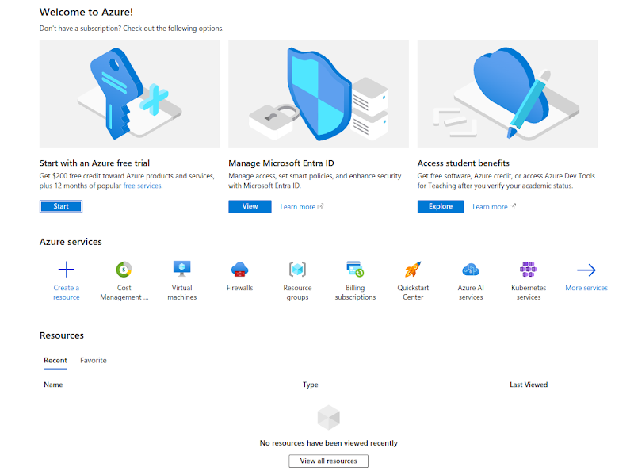
- 2. Click on Start free
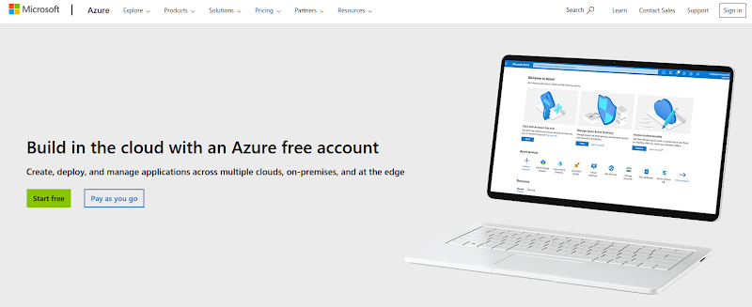

- 3.After selecting your account to begin, you will be directed to a signup page to fill in more information, check the box I agree to the customer agreement, and press Next.
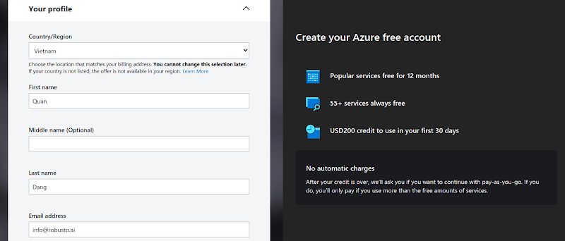

- 4. Please proceed to enter your credit/debit card information now. Please note that $1 will be deducted from your account for verification and then refunded, so please ensure that you have at least $1 in your account.
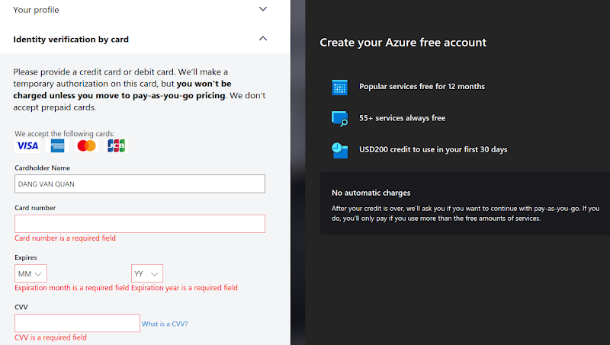
- 5. Click Next. Azure will prompt you to sign in again before displaying You're ready to start with Azure.
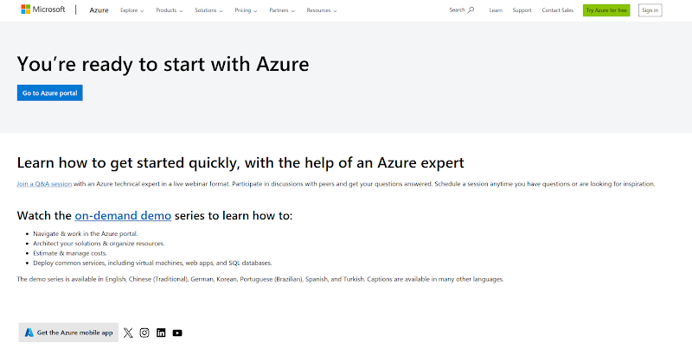
- 6. Go to the Azure portal at https://portal.azure.com/, and you should see the below image.
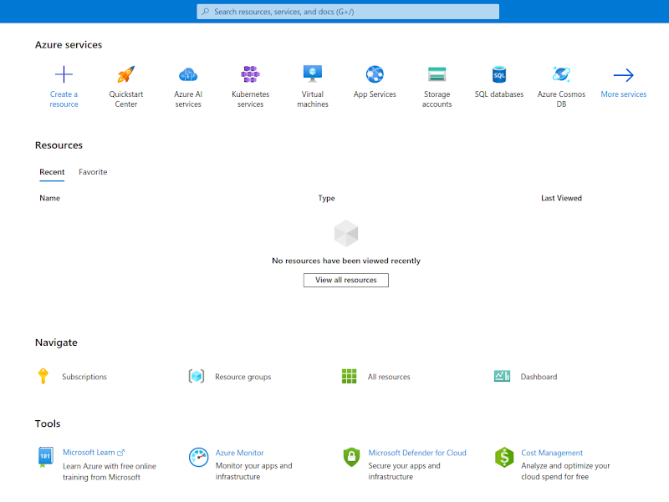
- 7. Similar to the guide Create a VM on GCP, you can create one on Azure.

